JP-58 WIFI User Manual

一．How to get WIFI printer to join router.

1 Remove the paper after start ON printer (paperless state red flashing)

2 Press the button FEED (this time the red light will be off, press and hold 5 seconds), wait for the red light.

3 release paper

4. Printer access router, print out the IP
“IoTManager_v0.96 “ apk software copy to android phone
Open the apk on your phone

5.Enter the router's account (Ssid), enter the password (Password)
Start
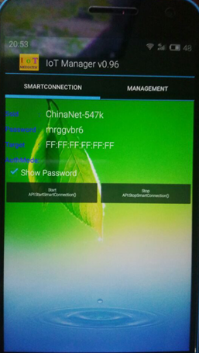

6.Wait 30 seconds (10 seconds or less) printer print IP address,
If there is no print IP address for 30 seconds, then point stop, point start, and then continue to try to start from step 1.

- How to test the printer has joined router

- Open “GongDao”apk

- Enter the printer to print out the IP address (for example, 192.168.191.1),

- Click Connect 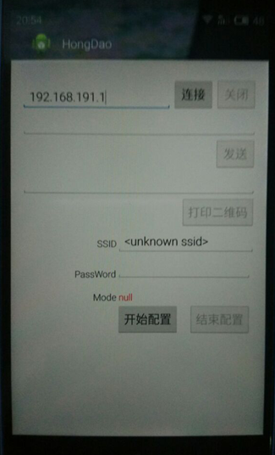

4Enter text print, enter the QR code print

- Use computer test
- Install the printer driver, POS58, port USB, baud rate 9600
- Open the Printer Properties
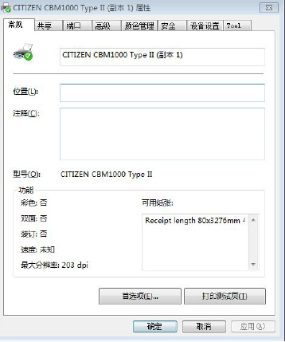
- Select a port, add the port
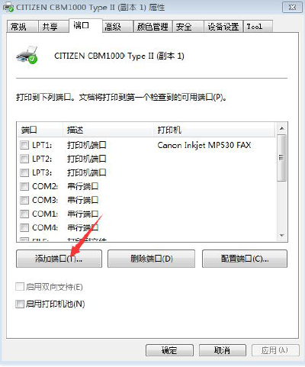
- Select Standard TCP / IP Port and click New Port, and then click Next
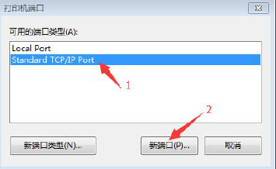
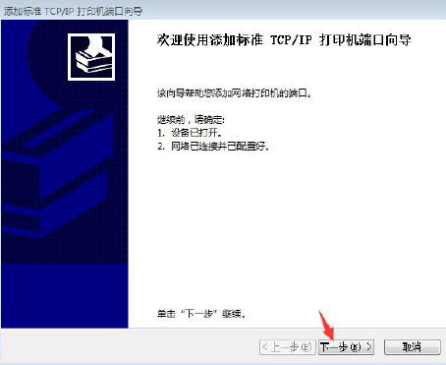

- After entering the IP address of the printer click Next
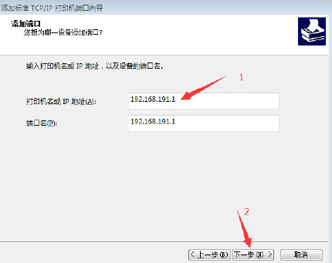

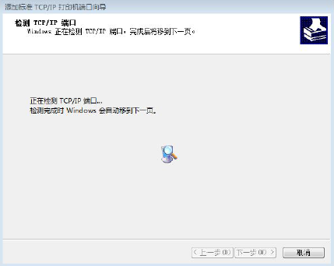

6.Select Custom, then press the Set

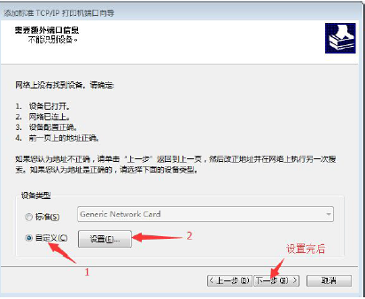

7.Set as follows (the port name and printer name without modification), then press OK, and Next, and then press Done
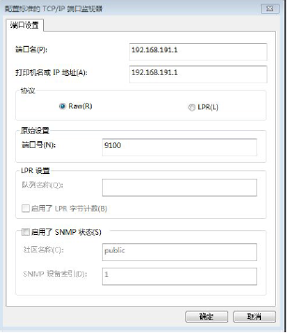
8.At this port list appears just added a printer port as follows
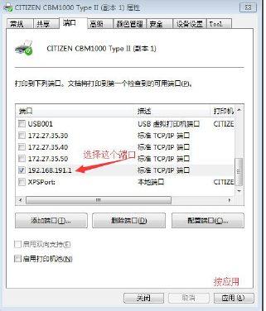
9.Return to normal bar, press to print a test page. The printer can print.
